**Storyboard sequence for creating a task**

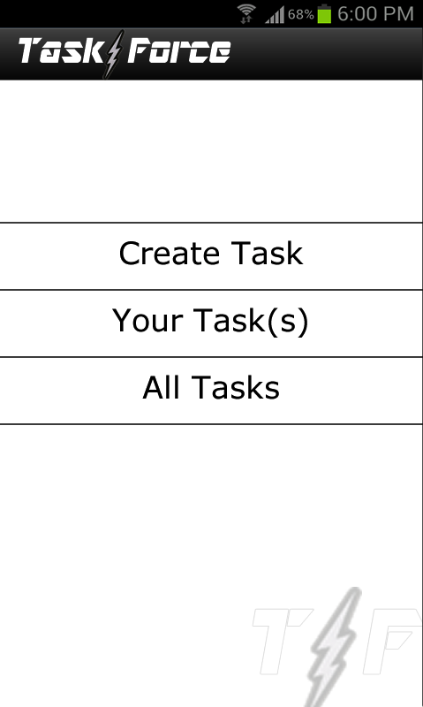

**Step 1** – Initiate create task

-Click the “Create Task” button

-This will take you to **STEP 2**

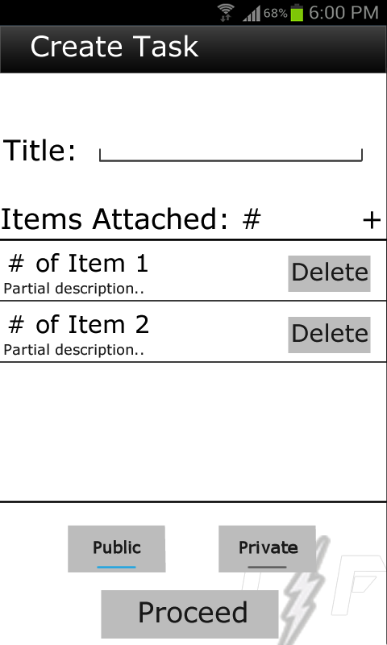

**Step 2** – Create Task Main Page

-Click the title text field to enter a title

-Click on the “+” to add a item to the task

-This will take you to **STEP 3**

NOTE: You can have at most one of each item selected for a task

-Select “Public” if you want the task to be available to everyone

-Select “Private” if you want the task to stay local

-Click “Save Task” when you have all the tasks you require

-This will prompt saying the task was saved and return to the main menu

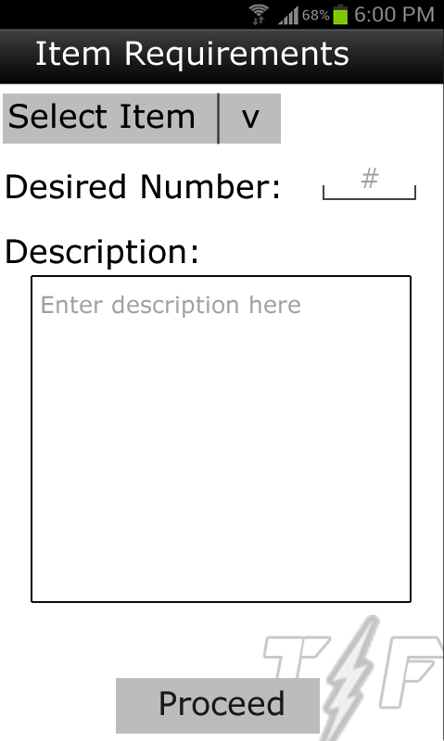

Step 3 – Item selection screen

-Click the “Select Item” and a drop down list with the available item types will appear for you to select

-Audio

-Text

-Photo

-Click the Desired Number textbox and enter your value

-Click the Description textbox and enter the description of the item you are looking for

-Click “Proceed”

-This will take you back to **STEP 2**, but the item you

created for the task will be listed and the items

attached list will be updated